**Embedded System Diploma Online**

**Lab 2 Report**

**Name: Ahmed Emad Hassan**

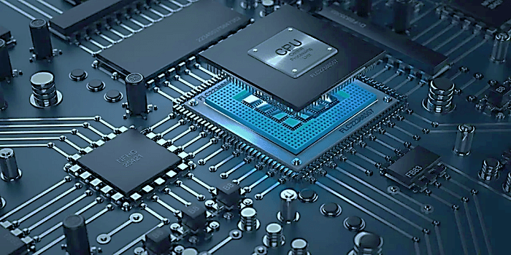

Table of Contents

Steps 3

Commands 3

Output from Qemu 3

Specs 3

Code 4

app.c 4

uart.c 4

uart.h 4

startup.s 5

Object files sections 7

app.o 7

uart.o 7

startup.o 8

# Steps

1. Create and implement app.c
2. Create and implement uart.h
3. Create and implement uart.c
4. Create and implement startup.s
5. Convert all c files (.c) to object files (.o)
6. Write linker script (.ld)
7. Apply linker script to all object files (.o) to get (.elf) file
8. Convert (.elf) file that contains debugging information to (.bin) file that doesn’t contain debugging information
9. Run the binary (.bin) on the board using Qemu simulator

# Commands

**Convert all c files (.c) to object files (.o)**



**Apply linker script to all object files (.o) to get .elf file**



**Convert (.elf) file to (.bin) file**



**Run the binary (.bin) on the board using Qemu simulator**



# Output from Qemu



# Specs

Entry point of processor is: 0x10000

To Activate UART0 you just write on UART0DR register (32bit)

And its address is :0x101f1000

# Code

## app.c

## uart.c

## uart.h

## startup.s

**

# Object files sections

## app.o

## uart.o

## startup.o

